
EICHA @Aidacare

Overview
ECHIA is a business-critical EDI integration platform used by Aidacare to automate purchase order intake, validation, pricing verification, customer/item mapping, invoice communication, and order creation workflows for strategic customers.

The platform is AWS-hosted, supported by Envisage and Travis, and tightly integrated with Microsoft Dynamics GP through eConnect-based integrations. ECHIA supports both automated order creation and assisted/manual customer service workflows depending on customer integration models.

Application Overview

Area | Details
Application Name | ECHIA  https://echia.envisageapi.com
Business Function | EDI & Order Integration Platform
Hosting | AWS
Support Vendor | Envisage
Key Contact | Travis/Envisage
Criticality | Tier-1 / High Risk
Core Purpose | EDI order processing & integration
ERP Integration | Microsoft Dynamics GP
Integration Method | eConnect
Pricing Integration | OmniPrice
Customer Types | Auto-integrated & assisted/manual

Business Capabilities
- EDI order intake
- Customer mapping
- Item mapping
- Pricing validation
- GP quote/order creation
- Invoice communication
- Exception management
- Customer service workflows
Customer Type

Customer Type | Workflow
Fully Integrated Customers | ECHIA → GP automated
Assisted Customers (e.g. BUPA) | ECHIA email → Customer Service → CMP → GP

Workflow:
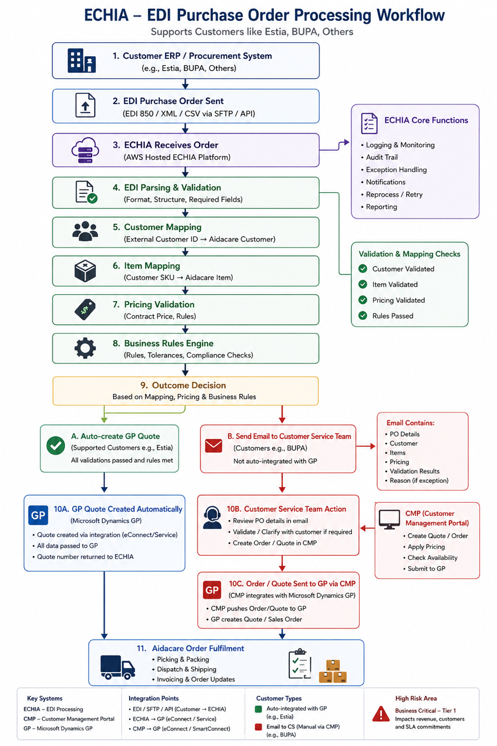
App Screens to see and resolve errors:

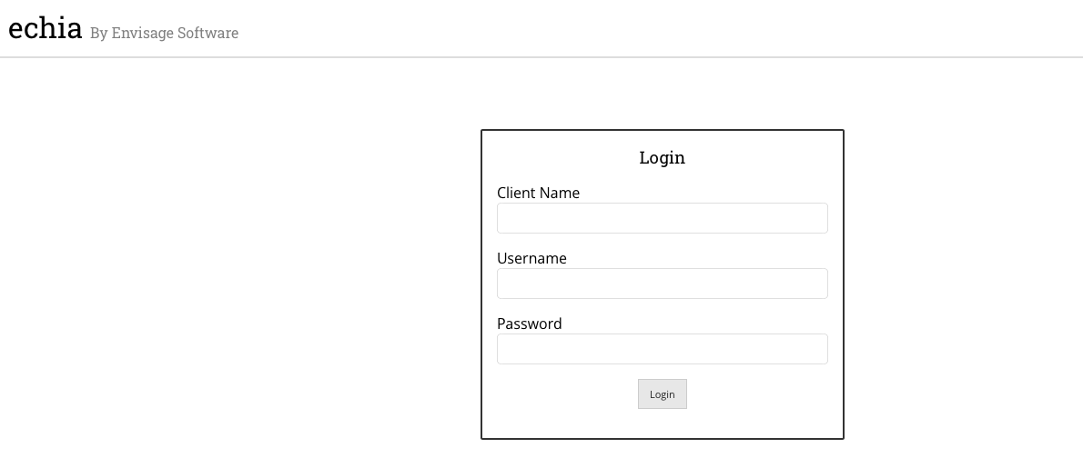
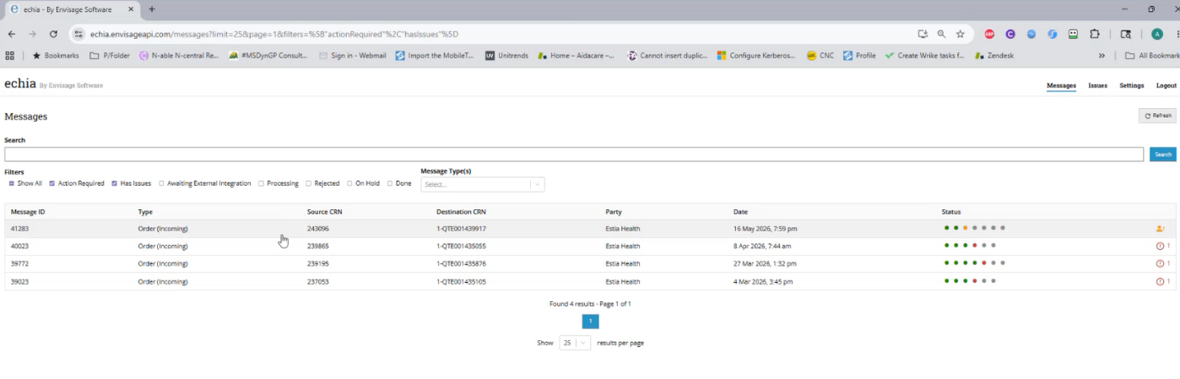

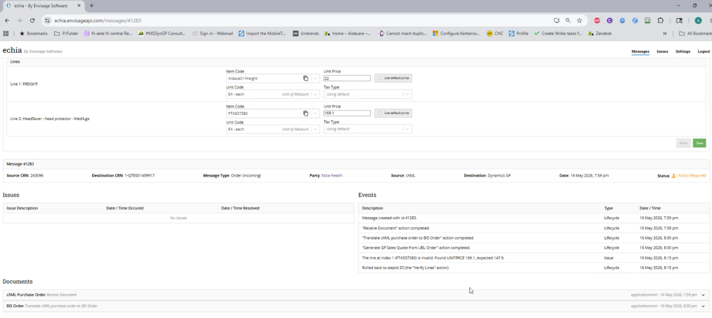

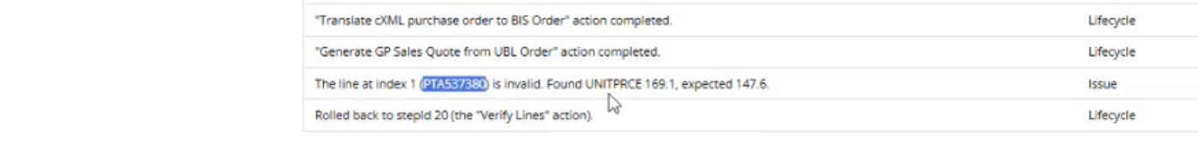
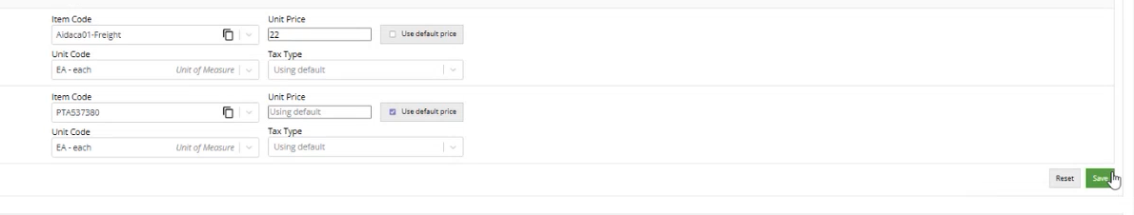

Production Issues (e2e):

Issue Category | Typical Symptoms | Possible Root Causes | Troubleshooting Approach | Resolution / Recovery Actions | Business Impact
EDI Order Not Received | • Customer claims PO sent  • No order visible in ECHIA | • SFTP/API failure  • EDI file transmission issue  • AWS service outage | • Check inbound EDI logs  • Validate SFTP/API connectivity  • Review CloudWatch/application logs | • Reprocess inbound file  • Restore connectivity  • Coordinate resend from customer if required | Orders not processed; revenue delay
EDI Parsing Failure | • Order rejected during processing  • Invalid file format errors | • Malformed XML/CSV  • Missing mandatory fields  • Unsupported EDI structure | • Review parsing logs  • Validate payload structure  • Compare with expected schema | • Correct mapping/schema rules  • Reprocess corrected file | Customer order processing failure
Customer Mapping Failure | • Customer not recognized  • Invalid customer errors | • Missing customer mapping  • Incorrect external customer ID  • Inactive GP customer | • Check customer mapping tables  • Validate GP customer status | • Correct mapping  • Activate/update customer record | Order creation blocked
Item Mapping Failure | • Unknown SKU errors  • Order lines rejected | • Customer SKU not mapped  • GP item inactive  • UOM mismatch | • Review item mapping tables• Validate GP item setup | • Add/correct item mapping  • Reprocess order | Incorrect or failed fulfilment
Pricing Validation Failure | • Pricing mismatch  • Order exception email triggered | • Contract pricing mismatch  • OmniPrice failure  • Invalid customer pricing | • Validate OmniPrice response  • Compare contract pricing  • Review pricing rules | • Correct pricing configuration  • Reprocess transaction | Financial/customer impact
GP Quote/Order Creation Failure | • ECHIA processed successfully  • No quote/order created in GP | • eConnect failure  • GP validation error  • SQL deadlock | • Review eConnect logs  • Validate GP integration services  • Check SQL errors | • Restart integration service  • Correct GP validation issue  • Replay transaction | Order fulfilment blocked
Duplicate Order Creation | • Multiple quotes/orders for same PO | • Retry logic issue  • Duplicate EDI resend  • Queue replay issue | • Compare PO references  • Review retry/replay logs | • Cancel duplicate transactions  • Adjust retry logic | Financial & operational risk
Invoice Delivery Failure | • Customer not receiving invoice  • Email bouncebacks | • SMTP issue  • Invalid email  • Queue failure | • Review email delivery logs  • Validate SMTP status | • Resend invoice  • Correct email config/address | Cashflow & customer dissatisfaction
Exception Email Not Sent | • Order failed silently  • No alert to customer service | • SMTP failure  • Notification service issue | • Validate notification queue  • Check mail server logs | • Restart notification service  • Replay failed notifications | Missed orders / delayed processing
AWS Infrastructure Issue | • Application unavailable  • Integration failures  • Slow processing | • EC2 outage• RDS issue  • Security group/network issue | • Review CloudWatch• Validate EC2/RDS health  • Check networking | • Restart affected services  • Failover/recovery actions | Major business interruption
Queue Backlog / Delayed Processing | • Orders delayed  • Slow integration processing | • Queue congestion  • Integration bottleneck  • Large batch processing | • Review queue depth  • Monitor processing time | • Restart workers/services  • Clear stuck queue items | Delayed order fulfilment
Manual Workflow Failure (BUPA/CMP Flow) | • Email received but no GP order created  Include eCommerce team | • Customer service missed email  • CMP integration issue | • Trace workflow from email → CMP → GP | • Manual order creation  • Reprocess through CMP | Delayed customer fulfilment
OmniPrice Integration Failure | • Pricing validation unavailable  • Incorrect pricing applied | • OmniPrice outage  • API/database connectivity issue | • Validate OmniPrice service response  • Review integration logs | • Restore connectivity  • Temporary manual pricing validation | Financial/compliance impact
eConnect Service Failure | • GP transactions not posting | • Service stopped  • Invalid payload  • GP connectivity issue | • Review eConnect logs/services  • Validate GP access | • Restart eConnect  • Correct payload data | ERP integration outage
SQL Deadlocks / Performance Issues | • Slow order processing  • Transaction failures | • Concurrent updates  • Blocking sessions  • Poor indexing | • Review SQL blocking/deadlocks  • Analyze query performance | • Kill blocking sessions  • SQL optimization/indexing | Processing delays
Incorrect Invoice / Customer Communication | • Wrong customer receives invoice | • Mapping issue  • Merge/template issue | • Validate customer mapping  • Review email generation logic | • Correct mappings/templates• Compliance incident handling | Privacy/compliance risk
Failed Reprocessing / Retry Loop | • Same order repeatedly failing | • Permanent validation issue  • Queue retry logic problem | • Analyze repeated error logs  • Review replay mechanism | • Correct root cause  • Clear retry queue safely | Queue congestion / duplicate risk
Application Login / Access Issues | • Users cannot access ECHIA | • AD/authentication issue  • Expired credentials  • AWS/network issue | • Validate authentication logs  • Check account status | • Reset credentials  • Restore access | Operational support delays
Audit / Traceability Gaps | • Unable to trace order lifecycle | • Logging gaps  • Queue cleanup issue | • Review audit logs  • Validate transaction tracking | • Restore logging configuration  • Enhance monitoring | Support & compliance risk

