
Freight@Aidacare
FreightMaster, SmartFreight, Radaro
Freight Master  Operational control  This application is sometimes also referred as SmartFreight. Earlier there was no Radaro and Freight Master was only having SmartFreight integration. That’s why in GP it is still referred to as SmartFreight. | Application | 1 | Back-office freight management system  http://10.26.21.49/8080 | TBC
 | App Server | 2 | Freight Master Installation | AIDASMFR01V
 | Database Server | 3 | Database for Freight Master | AIDASMFR01V
 | Database | 4 | DB name | GP Database, HANDR
 | Tech Stack | 5 | React+NodeJS, SQL Server GP
 | Integrations | 6 | SmartFreight, Radaro, MS-GP
 | Support | 7 | Travis, Envisage

SmartFrieght  Integration | SaaS | Courrier using external agencies | API Details: TBC
Radaro Integration | SaaS | Internal Drivers | API Details: TBC

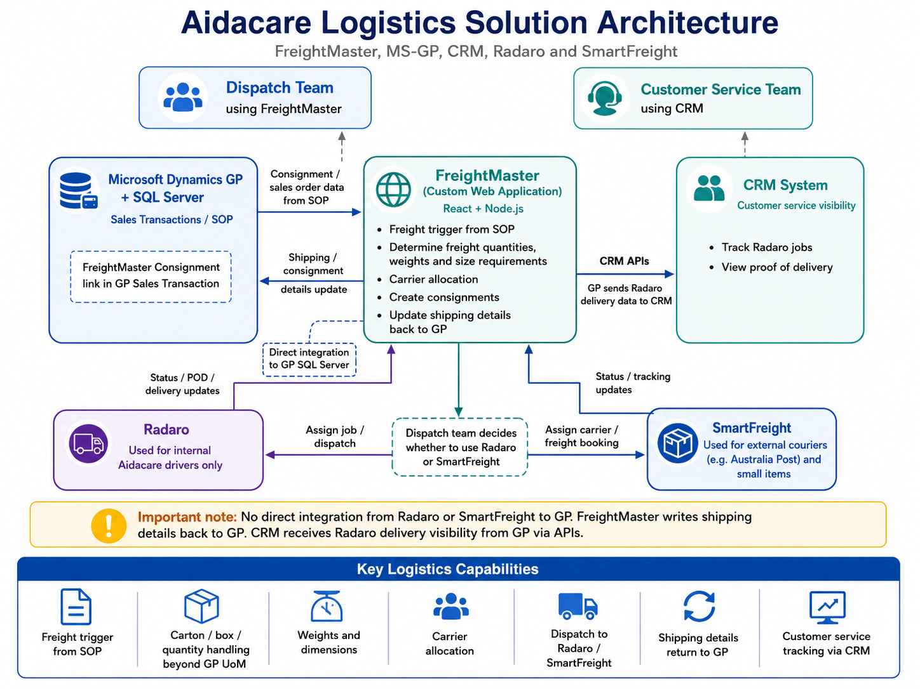

FreightMaster (Sometimes also referred to as SmartFreight in GP) is a multi-carrier shipping and manifest management platform. In this environment, it functions as a Service-Oriented Architecture (SOA) that sits between the ERP (Dynamics GP) and external delivery platforms like SamrtFreight and Radaro. It standardizes how delivery data is captured and transmitted.

What is it used for?
- Data Translation: Converts complex GP Sales Orders into a simplified "Consignment" format.
- Carrier Routing: Determines if a delivery should go to an external courier or to the internal Radaro driver pool.
- Validation: Ensures that addresses, phone numbers, and location codes are present and valid before attempting to "Import" them to the cloud.
- Centralized Logging: Provides a single SQL-based audit trail for all outgoing shipments.

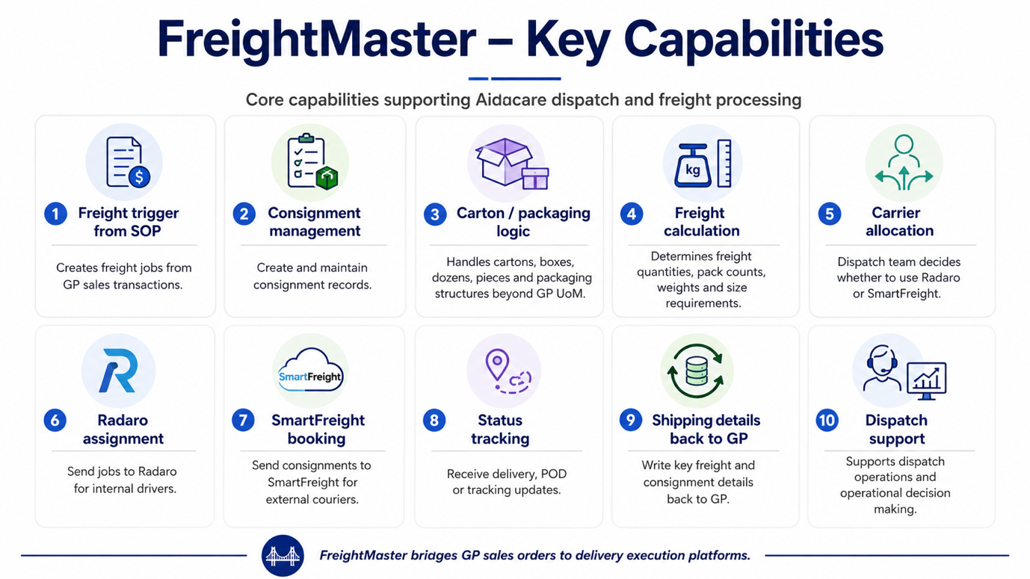

How it Connects GP and Radaro & SmartFreight

FeightMaster serves as the Logic Layer. It does not perform the delivery itself; instead, it creates the "Instructions" for the delivery.
- From GP: It monitors the Sales Transaction windows for specific triggers. Freight Master is launched from GP from sales transaction window.
- To Radaro: It identifies when a specific carrier or shipping method is assigned and uses a background service to "push" that specific data packet to the Radaro API.
- To SmartFreight: It identifies when a specific carrier or shipping method is assigned and uses a background service to "push" that specific data packet to the SmartFreight API.
- To GP: It is directly integrated with GP SQL DB.

Related Tables
These tables (located in the HANDR database) form the data repository for the FreightMaster logic.
Table Name | Description
ConsignmentRequests | The primary staging table where GP data is stored after being "Logicalized" by SmartFreight.
ConsignmentRequestStatus | Defines the lifecycle of the logic (Draft $\rightarrow$ Processing $\rightarrow$ Imported).
ConsignmentRequestHistory | Records the timeline of the "Brain's" actions, including error logs if a push fails.
ConsignmentRequestReferences | Maps internal GP Order Numbers to external Radaro/Carrier IDs.

Stored Procedures (SPs)
These procedures are the "Active Intelligence" of the SmartFreight system.
- smartFreightConsignmentRequestCreate
The main engine used to insert new delivery requests into the staging tables.
- smartFreightConsignmentRequestSecurity
Handles the authentication logic, ensuring the correct API keys are used for the specific warehouse location.

Logic File (vstcontrols.smartfright.dll)
This .dll file, located in the GP Addins folder, is the primary suspect for the integration's "Front-End" behavior.
- Potential Function: There are strong indications that this file "hooks" into the Dynamics GP user interface. It likely monitors UI events (like button clicks) to trigger the SmartFreight logic.
- Disclaimer: As this is compiled code, the exact internal mappings remain unconfirmed; however, its presence in the Add-ins folder suggests it is the bridge that initiates the hand-off from the GP window to the SQL stored procedures.

End-to-End Flow: GP -> SmartFreight -> Radaro
- Origin (GP): A user enters a Sales Order in Dynamics GP. Upon saving, the .dll logic file detects the transaction.
- Logic Processing (SF): The logic file calls the smartFreightConsignmentRequestCreate stored procedure. This procedure reads the order details and writes a new record into the ConsignmentRequests table with a status of "Draft" (1).
- Validation (SF): The system checks the ConsignmentRadaroApiKeyMappings to ensure a valid connection exists for that warehouse location.
- The Hand-off: A background service (The Messenger) detects the "Draft" record, converts it into a JSON payload, and sends it via HTTPS to the Radaro API.
- Completion (Radaro): Radaro receives the job, creates a task for the driver, and sends a "Success" message back.
- Final Update: The background service updates the SQL table status to "Imported" (3) and records the Radaro Job ID in the consignmentNo column.

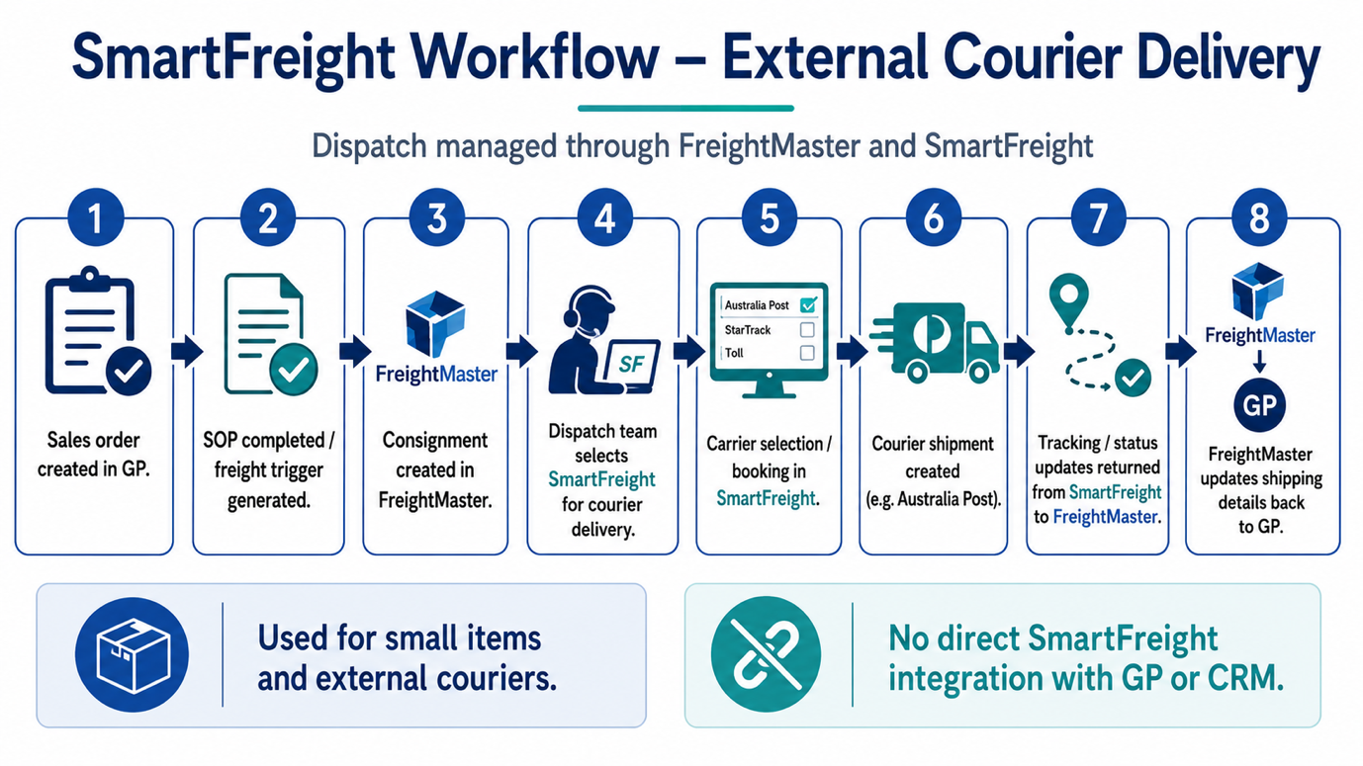

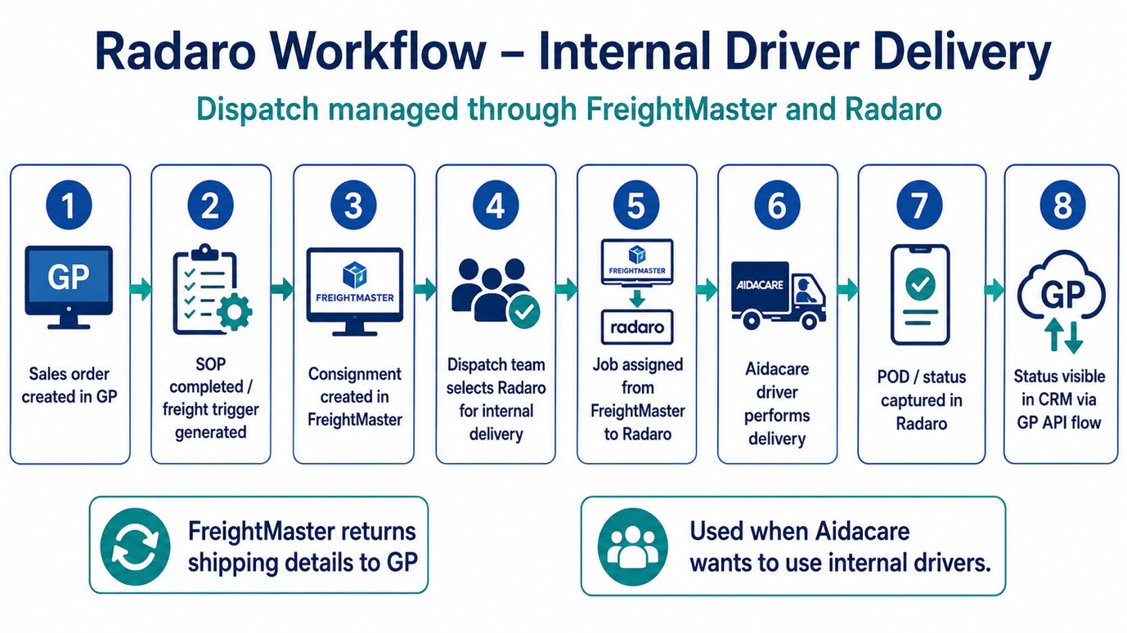

Radaro is a cloud-based enterprise logistics and last-mile delivery management platform. It acts as a digital bridge between the dispatch office and the driver's mobile device, providing real-time tracking and proof of delivery.

What is it used for?
- Live Driver Tracking: Provides a real-time "Uber-style" view of drivers on a map for dispatchers.
- Customer Notifications: Automatically sends SMS or email alerts to customers with a live tracking link when their delivery is "on the way."
- Digital Proof of Delivery (POD): Captures signatures, photos, and GPS timestamps via a mobile app, eliminating paper manifests.
- Route Optimization: Uses AI to sequence deliveries for the most efficient path, reducing fuel and time.

How it talks to Dynamics GP
The integration follows a "Staging & Sync" model. It does not communicate with GP’s core tables directly; instead, it uses a middleware framework (managed via FreightMaster) to move data.
- The Trigger: When a Sales Order (SOP) is saved or processed in GP, a SQL Trigger or Add-in captures the order details.
- The Staging: The data is written into a set of "Consignment" tables in the HANDR database.
- The Handshake: A background Windows Service identifies the new record, looks up the API Key associated with the GP Location Code, and sends the payload to the Radaro Cloud API.
- The Loop: Once Radaro accepts the job, it sends back a unique consignmentNo (Job ID) which is written back to the GP staging tables to confirm a successful hand-off.

Integration Tables
These tables reside in the HANDR database and serve as the data repository for the Radaro integration.
Table Name | Description
ConsignmentRequests | The master header table; links GP SOPNUMBE to Radaro job details.
ConsignmentRadaroApiKeyMappings | Stores the unique Radaro API credentials for each GP Warehouse/Location.
ConsignmentRequestStatus | A reference table defining the integration state (e.g., 1=Draft, 3=Imported, 4=Failed).
ConsignmentRequestHistory | An audit log tracking every status change and timestamp for a delivery request.
ConsignmentRequestReferences | Stores external IDs and cross-references between GP and the Radaro cloud.
ConsignmentRequestRadaroLabels | Stores metadata tags used to categorize jobs within the Radaro dashboard.
ConsignmentRequestRadaroDriverSkills | Maps specific driver requirements (e.g., "Heavy Lift") to the delivery job.

Stored Procedures (SPs)
These procedures contain business logic that governs how data is formatted and secured.
- smartFreightConsignmentRequestCreate
The primary engine that gathers data from GP Sales tables and populates the ConsignmentRequests table to initiate a delivery.
- smartFreightConsignmentRequestSecurity
The authorization layer that validates the API Keys and ensures the connection to Radaro is secure before data is transmitted.

