
POS@Aidacare
EFTPOS@Aidacare
Westpac Payway@Aidacare
Envisage POS (Point of Sale System) – IP is with Envisage.
POS | Application | 1 | pos.aidacare.com.au | POS Admin
POS | App Server | 2 | POS Application Server | AIDAPOS01V
POS | Database Server | 3 | POS Database Server | GP DB, SQL Server
POS | Database | 4 | POS Database | HANDLR (GP DB)
POS | URL | 5 | www.pos.aidacare.com
POS | Integration | 6 | - Direct GP SQL Server connection  - Westpac Payway integration  - EFTPOS Linkly integration
 | Support | 7 | Envisage, IP is with Envisage
 | Technology | 8 | React, NodeJS

EFTPOS  Physical card machines | Used for physical card payments in store  Integrated with POS through Linkly  Payment processing through Westpac merchant services | In-store EFTPOS payments  POS → Linkly → Westpac EFTPOS terminal / Westpac merchant service
EFTPOS  Physical card machines | Support | Aidacare GP team
Westpac Payway | Used for non-physical card payments.  Integrated with POS  Integrated with MS-GP (Modification in GP ( Document created for GP modification ) | Credit card gateway / card-not-present payments/ phone/stored card etc...  POS / application → Westpac PayWay → Westpac payment processing
Westpac Payway | The GP customisation allows credit card payments, refunds, prepayments, and reversals to be processed directly within the Sales Payment Entry window in Dynamics GP. The integration is implemented using a Dexterity-based dictionary customisation with a .NET integration component that communicates with the PayWay API.
Westpac Payway | Support | Aidacare GP Team

System Overview:
Envisage POS provides a custom retail Point of Sale (POS) platform tailored for Aidacare retail operations.  The platform enables retail staff to:  - Process customer sales  - Accept payments  - Handle refunds  - Capture customer details  - Process retail invoices  - Update inventory | The system is tightly integrated with GP to ensure:  - Accurate inventory visibility  - Financial reconciliation  - Centralised customer management  - real-time order synchronisation  - Consistent sales and operational reporting
EFTPOS + Westpac Merchant services | For Aidacare, EFTPOS is used when a branch staff member processes a retail sale, refund, or payment through the custom POS application and the customer pays at the counter. The POS sends the transaction amount to the EFTPOS terminal, the customer taps/inserts/swipes their card, and the terminal returns an approved or declined response.  Aidacare’s EFTPOS integration use Linkly as the middleware between the custom POS application and the Westpac EFTPOS terminal/payment service. Linkly allows the POS to communicate with the terminal, send the payment amount, receive the transaction response, and support functions such as refunds, receipts, and transaction status. Linkly describes its in-store integration as connecting POS solutions with EFTPOS terminals to reduce manual keying and payment errors.
Westpac Payway | Westpac PayWay is Westpac’s credit card payment gateway. It allows business applications to process credit card payments through Westpac’s payment processing services. PayWay can be used for card-not-present payments such as online payments, phone payments, payment portals, software-driven payments, API-based payments, and recurring/customer reference-based payments.

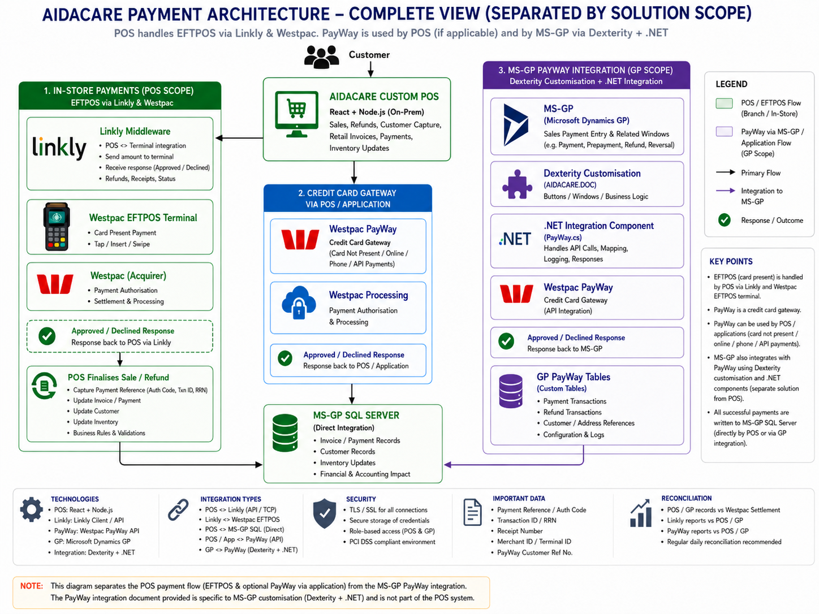

POS Capabilities:
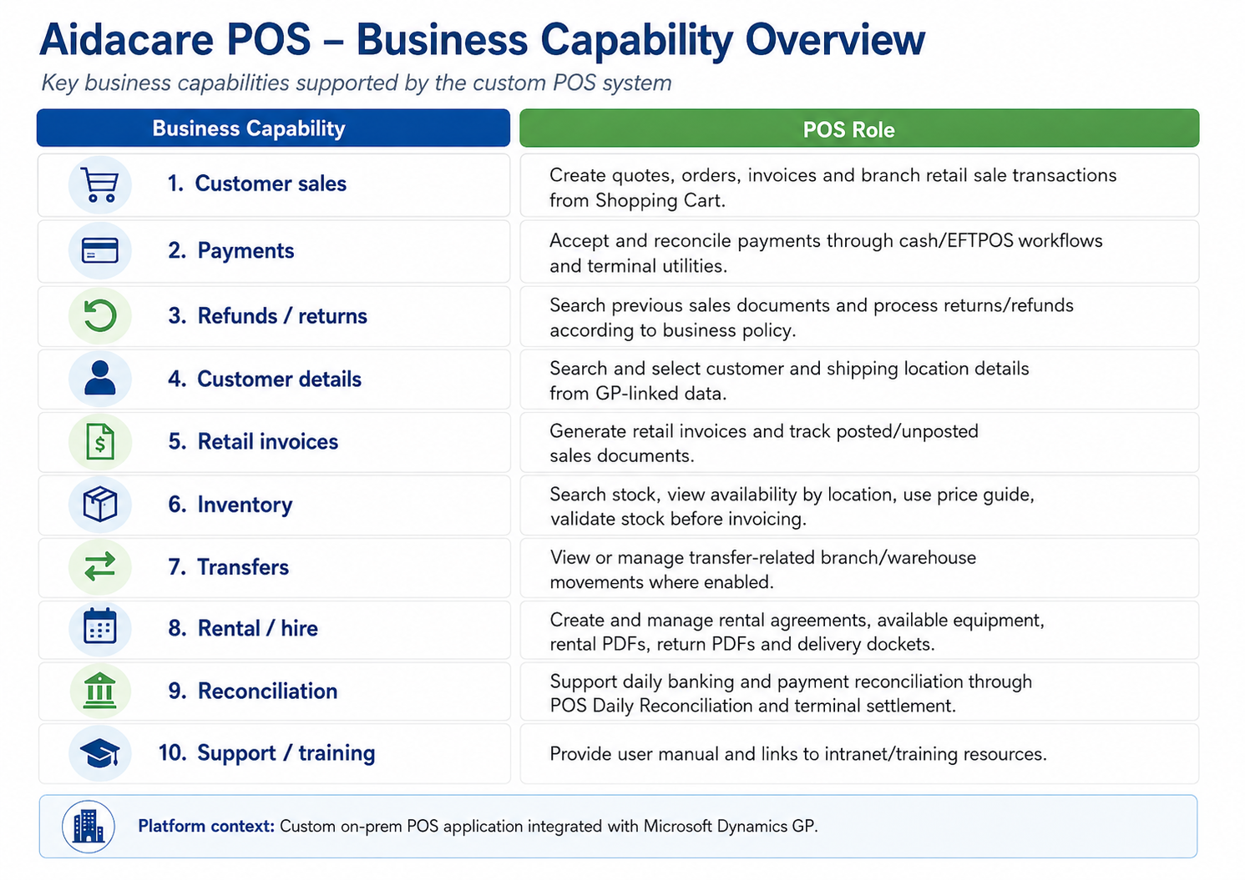

EFTPOS – POS Data flow: ( Need to validate with POS team)
Step | From | To | Data / action exchanged | Done through Linkly? | Notes
1 | POS | POS user/session | User selects Pay by EFTPOS | No | This is inside Aidacare POS.
2 | POS | Linkly | Payment request | Yes | POS sends transaction type, amount, invoice/receipt reference, terminal/register details where configured.
3 | Linkly | EFTPOS terminal | Transaction amount | Yes | Amount appears on the terminal; staff should not need to manually key it.
4 | EFTPOS terminal | Customer/card | Tap / insert / swipe / PIN | No | This happens on the physical terminal.
5 | EFTPOS terminal | Westpac | Authorisation request | Partly | Linkly connects POS to terminal; Westpac/bank network handles payment authorisation.
6 | Westpac | EFTPOS terminal | Approved / declined / cancelled / timeout result | No / terminal-bank side | This is the bank/acquirer outcome.
7 | EFTPOS terminal | Linkly | Transaction response | Yes | Linkly receives the terminal/payment response.
8 | Linkly | POS | Approved/declined response, transaction reference, receipt data | Yes | POS must inspect the actual EFT response, not only HTTP/API status. Linkly documentation specifically warns that HTTP 200/202 does not by itself mean the payment succeeded. (Linkly)
9 | POS | POS database / MS-GP SQL | Finalise sale/refund/payment/inventory update | No | This is Aidacare POS logic and GP SQL integration, not Linkly.
10 | POS / Finance | Westpac / settlement reports | Reconciliation | Partly | Linkly/POS transaction refs help match POS, terminal, Westpac settlement and GP records.

What data is passed from POS to Linkly / EFTPOS (Need to validate with POS team)
Data element | Purpose
Transaction type | Purchase, refund, reversal/status/logon depending on function
Amount | Sale or refund amount to display on terminal
POS transaction ID / receipt number | Helps trace the payment back to the POS sale
Register / terminal identifier | Helps route to the correct EFTPOS terminal
Merchant / terminal configuration | Usually configured in Linkly/terminal setup
Refund reference | Required for matched refunds where applicable
Optional surcharge / cash-out / tipping fields | Only if enabled in the merchant/terminal setup

What data comes back from Linkly / EFTPOS to POS ( Need to validate with POS team)
Data returned | Why POS needs it
Approved / declined flag | Determines whether POS can finalise the sale
Response code / response text | Helps support team troubleshoot declines/errors
Approval code | Used for audit and reconciliation
Receipt number / transaction reference / RRN / RFN | Used for traceability, refund and settlement matching
Terminal ID / merchant ID | Helps identify which branch/register processed the payment
Receipt content | Used for customer/merchant receipt printing or reprint
Status result | Used when POS needs to recover after timeout, crash or unknown state

Changes in POS for EFTPOS ( need to validate with Envisage/GP team)
Area changed in POS | Change
Payment method screen | Added/updated payment option for EFTPOS / Card alongside cash or other payment types.
Send amount to terminal | POS sends sale/refund amount to Linkly, which passes it to the Westpac EFTPOS terminal.
Terminal utilities | Added functions such as Poll Terminal, Terminal Logon, possibly settlement/status/reprint utilities.
Payment response handling | POS receives approved, declined, cancelled, timeout or failed response from Linkly.
Transaction reference capture | POS stores approval code, transaction ID, receipt number, terminal ID, merchant ID, RRN/RFN where available.
Refund flow | POS supports card refunds through Linkly/EFTPOS, usually linked to original sale/payment reference.
Receipt handling | POS may print or store EFTPOS receipt details returned by Linkly.
Daily reconciliation | POS supports daily banking/reconciliation using EFTPOS totals and terminal settlement references.
Branch/register configuration | POS needs branch, register, terminal, merchant and Linkly configuration.
Error handling | POS needs logic for timeout, declined payment, terminal offline, Linkly not responding, or payment approved but POS/GP update failed.
MS-GP update logic | Once payment succeeds, POS finalises sale/payment/invoice/inventory update in MS-GP SQL.
Security/configuration | POS or local service may store endpoint/configuration for Linkly connectivity, not card data.

Issue Severity:
Severity | Example | Action
P1 | All branches cannot process POS/EFTPOS payments | Immediate escalation to POS, infra, Linkly/Westpac and GP teams
P2 | One branch cannot process EFTPOS | Branch-level workaround, terminal/Linkly troubleshooting, escalate if unresolved
P2 | Payment approved but GP/POS incomplete | Stop retrying, reconcile transaction, correct records with finance approval
P3 | Individual invoice/customer/inventory sync issue | Investigate logs and correct transaction/master data
P4 | Receipt print issue, user setting issue, daily banking view issue | Standard support fix

POS & EFTPOS Triage ( Recommended) :

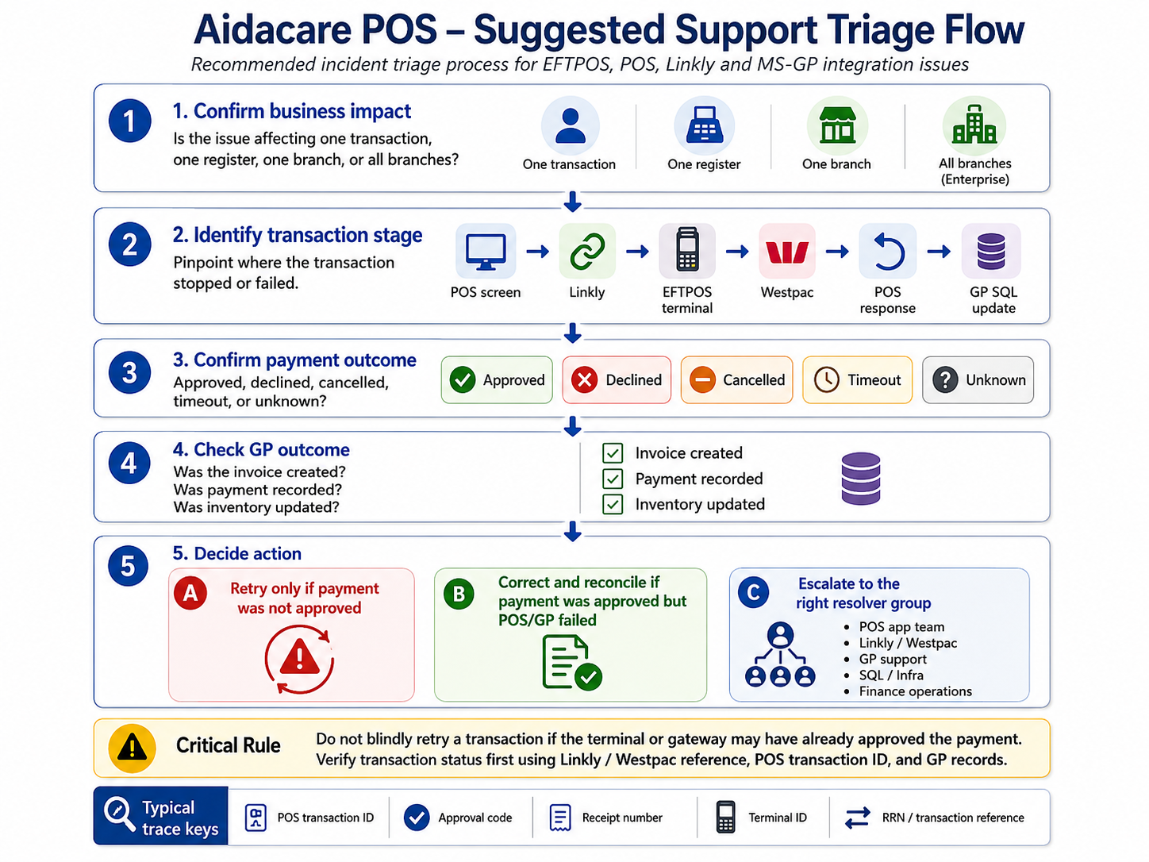

POS & EFTPOS Production Issues (This is as per P2S Experience for other clients)
Area | Common BAU issue / symptom | Likely cause | Troubleshooting checks | Resolution / action
POS application | POS screen not loading | POS web app/service down, browser issue, network issue, server unavailable | Check if only one register/branch is affected or all branches. Test POS URL from another machine. Check Node.js backend service status. Check browser console/network errors. | Restart POS backend service if required. Clear browser cache only if local issue. Escalate to infra/app support if POS service or server is down.
POS login | User unable to log in | Incorrect credentials, user inactive, role/branch mapping issue, authentication service issue | Confirm if other users can log in. Check user role, branch assignment and POS user configuration. Check backend logs for auth errors. | Reset/enable user access. Correct branch/role mapping. Restart auth/backend service if issue is system wide.
POS branch settings | EFTPOS option not visible or not working for a branch | EFTPOS not enabled in branch/user settings | Check POS branch settings, user settings and whether “Eftpos Enabled” is ticked. Confirm terminal configuration for the branch. | Enable EFTPOS in branch settings, save, restart POS client/local services, then perform terminal poll/logon test.
EFTPOS terminal | Terminal not responding from POS | Terminal offline, not paired, network issue, terminal switched off, Linkly service not connected | Check terminal power/network. Try “Poll Terminal” from POS/terminal options. Confirm terminal status and merchant/terminal ID. | Restart terminal. Reconnect network. Perform terminal logon. If still failing, escalate to Westpac/Linkly support.
Linkly | POS cannot send amount to EFTPOS terminal | Linkly client/service stopped, incorrect terminal pairing, local port/API issue | Check Linkly/PC-EFTPOS client is running. Check Linkly logs. Confirm POS can reach Linkly endpoint/local service. Check firewall/port blocking. | Restart Linkly service/client. Restart local POS client service. Re-pair terminal if required. Escalate if Linkly logs show terminal/API errors.
Linkly | Poll terminal fails | Terminal not connected, Linkly not communicating with terminal, bank network issue | Run Poll Terminal. Check Linkly connection status. Confirm terminal connectivity and terminal ID. | Restart terminal and Linkly service. Retry poll. If unsuccessful, contact Linkly/Westpac terminal support.
Linkly / Westpac | Terminal logon fails | Terminal cannot authenticate with bank/acquirer, merchant configuration issue, network outage | Run Terminal Logon. Check if issue affects one terminal or all branches. Review Linkly/terminal error message. | Retry after network check. Escalate to Westpac/Linkly if merchant/terminal authentication fails.
EFTPOS payment | Payment declined | Card declined, insufficient funds, bank/card issuer rejection | Confirm decline message on terminal/POS. Do not treat as system error unless multiple cards fail. | Ask customer for another card/payment method. No GP correction required if POS has not finalised sale.
EFTPOS payment | Payment approved on terminal but POS shows timeout/failure | POS did not receive final response from Linkly, network interruption, POS crash, Linkly response timeout | Check terminal receipt/customer receipt. Check Linkly transaction log. Check POS transaction status. Search POS/GP for invoice/payment record. | Do not reprocess immediately. First confirm transaction status using Linkly/Westpac reference. If payment approved but POS/GP incomplete, complete or correct transaction manually with finance approval.
EFTPOS payment | POS finalised sale but terminal did not approve payment | POS workflow defect, manual override, timeout incorrectly handled | Check POS transaction audit trail. Check Linkly/Westpac logs for approval code. Check GP payment record. | Reverse/correct POS/GP transaction if no valid payment exists. Capture incident and review POS validation logic.
Refund | Refund cannot be processed from POS | Original transaction reference missing, refund not allowed, terminal/bank restriction, user permission issue | Confirm original sale/payment reference. Check refund eligibility and user role. Check Linkly response. | Process refund using correct original transaction reference. If POS cannot refund, follow finance-approved manual refund path through terminal/bank portal and update GP/POS records.
Refund | Refund approved but GP/POS not updated | POS failed after payment gateway/terminal response, GP integration failure | Check Linkly/Westpac refund reference. Check POS logs and GP payment/refund records. | Manually reconcile and update/correct GP with finance approval. Record refund reference for audit.
POS sale processing | Sale cannot be completed | Mandatory fields missing, customer/account issue, item unavailable, pricing issue, inventory validation failure | Check POS error message. Verify customer, item, price, tax, warehouse/site and stock availability. | Correct missing/invalid data. Retry sale. If data is valid but error persists, check backend logs and GP SQL integration errors.
Customer capture | Customer details not saved or not visible in GP | POS validation issue, GP customer table update failed, duplicate customer, missing required GP fields | Check POS customer save response. Search customer in GP. Check POS backend logs and SQL error logs. | Correct mandatory fields. Reprocess customer creation/update. If duplicate exists, link sale to correct GP customer.
Retail invoice | Invoice not created in GP after POS sale | POS-to-GP SQL failure, SQL connectivity issue, transaction rollback, GP validation failure | Check POS transaction status. Check GP invoice/SOP tables. Review POS backend logs. Check SQL connectivity and errors. | If payment not taken, retry transaction. If payment taken, create/correct invoice in GP using controlled support procedure and reconcile payment reference.
Duplicate invoice | Same sale appears twice in GP | User retried after timeout, POS idempotency issue, delayed response from GP/SQL | Search by POS transaction ID, receipt number, customer, amount and time. Compare Linkly/Westpac payment references. | Void/reverse duplicate invoice according to finance process. Keep only the invoice linked to valid payment. Add prevention: unique POS transaction ID check before insert.
Inventory update | Stock not reduced after sale | Inventory update failed, wrong site/warehouse, item mapping issue, SQL transaction partially failed | Check item, site/warehouse, quantity and GP inventory records. Check POS transaction log. | Correct inventory movement in GP. Fix item/site mapping. Investigate why POS allowed sale without successful inventory update.
Inventory update | Wrong stock location updated | Branch/site mapping issue in POS configuration | Check POS branch-to-GP site mapping. Validate item/site in GP. | Correct branch/site mapping. Reverse wrong inventory movement and repost to correct site if required.
Pricing | Wrong price displayed in POS | POS pricing cache stale, GP/OmniPrice pricing not refreshed, customer class pricing issue | Compare POS price with GP/OmniPrice price. Check customer class/list/contract price. Check cache refresh timing. | Refresh POS pricing cache or sync process. Correct price source if master data issue. Raise defect if POS applies wrong pricing rule.
GP direct SQL integration | POS cannot connect to MS-GP SQL Server | SQL server down, network/firewall issue, SQL credentials expired/locked, connection string changed | Test SQL connectivity from POS server. Check SQL Server status, firewall, DNS, credentials and connection string. | Restore network/SQL access. Update credentials securely if expired. Restart POS backend after connection fix.
GP direct SQL integration | SQL timeout during sale/invoice update | Blocking, locks, slow query, SQL performance issue, large transaction volume | Check SQL activity monitor, blocking sessions, deadlocks, POS backend timeout logs. | Clear blocking only with DBA/GP approval. Optimise query/index if recurring. Avoid repeated retries during active lock.
GP data validation | GP rejects transaction or POS shows GP validation error | Missing customer/item/site/tax/payment mapping, invalid document type, posting period closed | Review POS error. Validate master data in GP. Check posting period, tax schedule, customer class, item/site. | Correct master data or transaction mapping. Reprocess once validation passes.
GP posting / accounting | Transaction exists but financial impact incorrect | Payment method mapping issue, GL account mapping issue, tax mapping issue, batch/posting issue | Check GP batch, payment type, distribution accounts, tax schedule and posting status. | Correct mapping. Post/repost batch as per finance approval. Raise change request if configuration defect.
Reconciliation | POS takings do not match Westpac settlement | Missing/duplicate POS transaction, approved payment not in GP, refund mismatch, settlement timing difference | Compare POS daily sales, Linkly reports, Westpac settlement, GP cash receipts/batches. Match by amount, date/time, terminal ID, approval code and transaction ID. | Prepare reconciliation exception list. Correct GP/POS records with finance sign-off. Do not alter payment records without settlement evidence.
Receipt printing | Receipt not printed or missing EFTPOS details | Printer issue, POS receipt template issue, Linkly receipt response missing | Test printer. Check POS receipt preview. Check Linkly receipt response/logs. | Restart printer/service. Reprint receipt if supported. Store transaction reference manually if receipt unavailable.
Daily banking | User cannot view daily banking reconciliation | User setting disabled, permission issue, branch setting missing | Check user/branch settings, especially daily banking reconciliation access. | Enable required setting and retest.
Offline / network outage | Branch cannot process card payments | Internet/branch network outage, terminal offline, Linkly cannot reach Westpac | Check if POS works locally. Check internet, terminal network and Linkly status. | Follow business continuity process: alternative payment method/manual process if approved. Reconcile all offline/manual transactions later.
Security / credentials | PayWay/Linkly/SQL integration suddenly fails after password/cert change | Expired credentials, certificate change, merchant credential rotation, service account locked | Check recent changes. Review logs for authentication/certificate errors. Confirm service account status. | Update credentials in secure config store. Restart affected services. Document credential expiry/rotation schedule.
Support ownership | Team unsure whether issue is POS, Linkly, Westpac or GP | Symptoms overlap across payment and accounting layers | Identify where the transaction stopped: POS screen, Linkly, terminal, Westpac, GP SQL, or GP posting. Use transaction ID/approval code as trace key. | Assign to correct resolver group: POS app team, Linkly/Westpac, GP support, SQL/infra, or finance operations.
EFTPOS – POS Setup |  |  |  | SOP exist for installing Linkly

