
Panatracker @Aidacare

Microsoft Dynamics GP = Core ERP
PanatrackerGP = Warehouse mobility/scanning layer on top of GP
NiceLabel: Label Management application

Panatracker | Application | 1 | http://10.26.21.85:81/  Admin Web App | PanatrackerGP 7.11.0.0 (Build 216)
Panatracker | App Server | 2 | Panatracker installation | AIDABCODE01V
Panatracker | Database Server | 3 | GP- DB Server 2019 | AIDASQL01P
Panatracker | Database | 4 | GP SQL Server DB | PanatrackerGP
Panatracker | Application | 5 | NiceLabel (on-prem) Has admin console | AIDABCODE01V
 | Integration | 6 | All out of the box
 | Support | MicroChannel for product support

PanatrackerGP helps Aidacare warehouse users:  - scan barcodes,  - receive inventory,  - pick orders,  - move stock,  - process transfers,  - dispatch shipments,  - track serialized equipment,  - use handheld devices.  Instead of typing manually into GP screens.  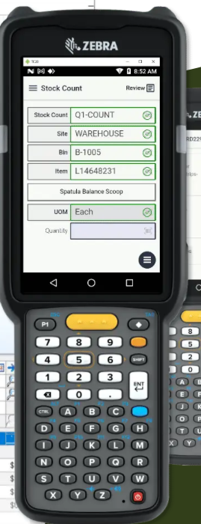 | Business processes supported by Panatracker:  - warehouse operations,  - serialized medical equipment,  - rental equipment movement,  - dispatch,  - stocktake,  - transfers,  - freight workflows.  Panatracker reads/writes GP data such as:  - inventory items,  - SOP orders,  - POP receipts,  - serial numbers,  - warehouse/bin data,  - transfers.
Without Panatracker process will be Slow and error-prone…..
Warehouse user manually:
- opens GP,
- types item numbers,
- enters serials,
- posts inventory movement.

User Interfaces:
System | User Interface | Primary Users
Microsoft Dynamics GP  PanatrackerGP | Citrix GP App | Finance, admin, inventory controllers
Panatracker Web App  http://10.26.21.85:81/ | 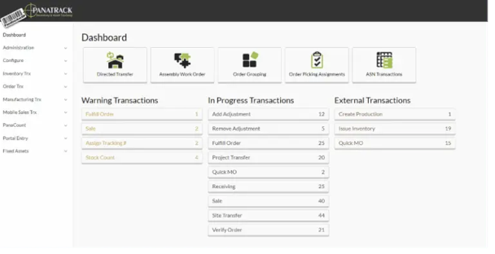 | Finance, admin, inventory controllers, IT
Panatracker Scanner  (Honeywell) | Mobile handheld scanner interface | Warehouse staff
NiceLabel | Label designer/admin console (usually limited users)  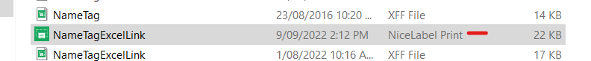  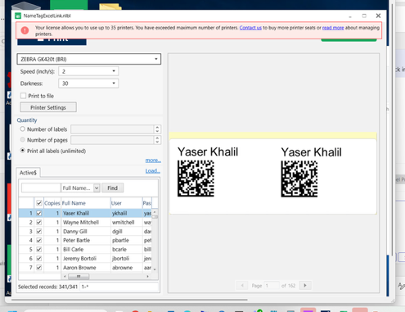 | IT/admin/support  Create a printer and printer get added to the server. Then Panatracker drop files to the printer to print.  Templates etc.. are out of the box from Panatrack
Printer interfaces | Zebra printer config utilities | IT/warehouse support

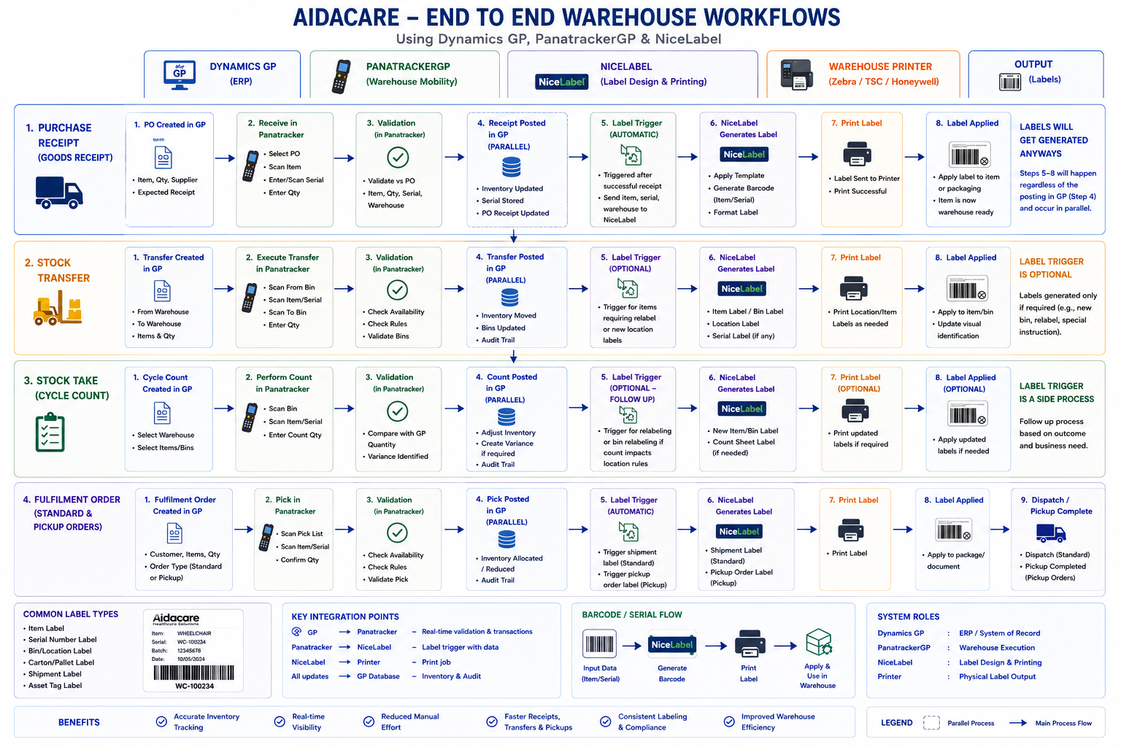

Workflow in detail:

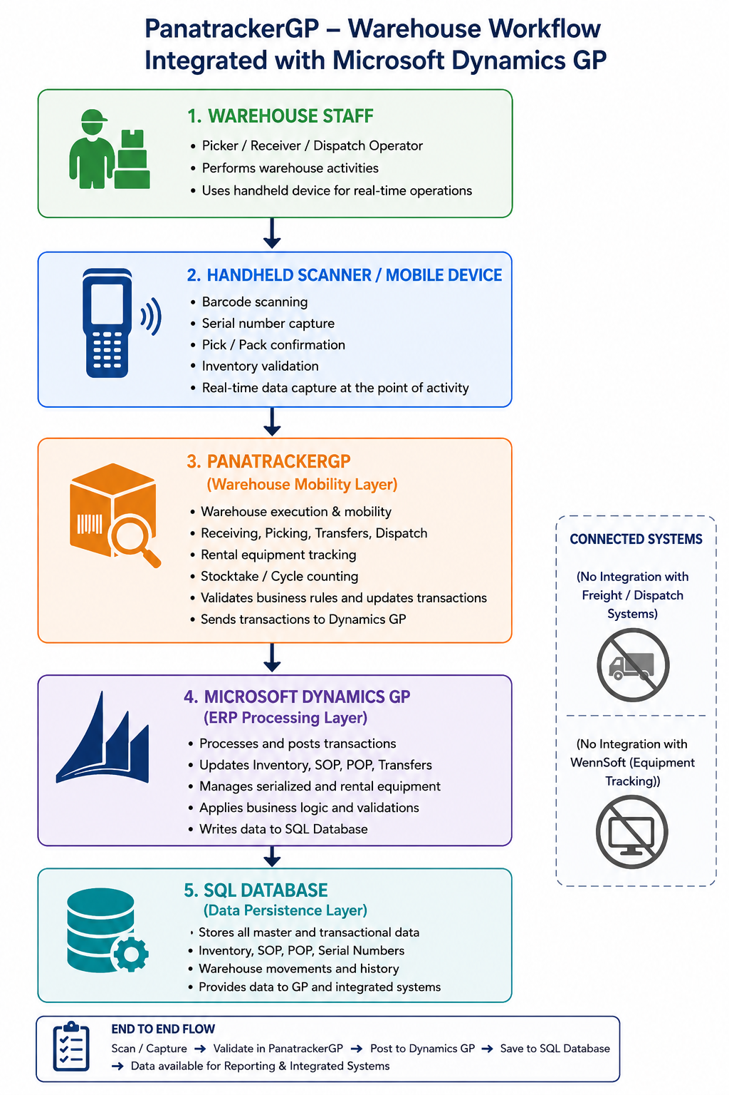

NiceLabel
NiceLabel is a barcode and label printing platform used in Aidacare alongside warehouse and ERP systems
In the Aidacare environment, NiceLabel is used to:
- generate barcode labels,
- print serial labels,
- print bin/location labels,
- print shipment labels,
- and support warehouse scanning operations.
NiceLabel Workflow:
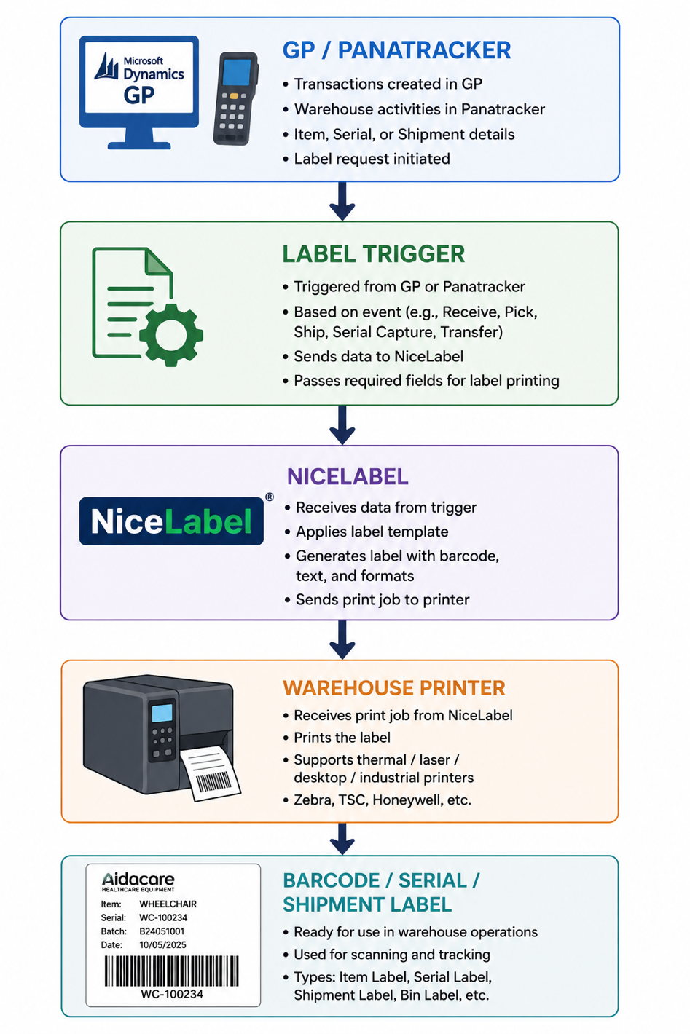

What NiceLabel Does

Label Type | Purpose / Usage | Information Printed | Example Use Cases | Integrated Systems
1. Barcode Label Printing | Used for identifying inventory items and serialized equipment | • Item number  • Serial number  • Barcode  • Description | • Wheelchair  • Medical equipment  • Rental assets | Microsoft Dynamics GP, PanatrackerGP, NiceLabel
Example Label | Example barcode/serial label generated during receiving or inventory processing | Item: WheelchairSerial: WC-100234Barcode: |||||||||| | Serialized equipment tracking | NiceLabel printers
2. Warehouse Bin Labels | Used for identifying warehouse locations, shelves, and storage bins | • Bin ID  • Warehouse location  • Barcode | • Shelf labels  • Warehouse aisles  • Storage zones | Panatracker warehouse scanning
3. Shipment / Carton Labels | Used for dispatch, shipment identification, and carton tracking | • Shipment ID  • Carton number• Customer details• Barcode | • Customer dispatch  • Carton tracking  • Shipment processing | Dispatch workflows, Panatracker shipment processing
4. Serialized Equipment Labels | Used for tracking serialized medical and rental equipment throughout lifecycle | • Equipment serial number  • Asset barcode  • Equipment ID | • Hospital bed  • Oxygen machine  • Wheelchair  • Rental equipment | GP serialized inventory, Panatracker tracking
5. Receiving Labels | Generated during PO receiving process for newly received stock | • PO number  • Item  • Serial number  • Barcode | • Goods receipt  • Inventory onboarding  • Warehouse receiving | Panatracker receiving workflows, NiceLabel printing
Receiving Workflow | Typical receiving label generation process | • Warehouse receives stock  • Panatracker scans receipt  • NiceLabel prints barcode labels | PO receiving operations | GP + Panatracker + NiceLabel ecosystem

Why Panatracker Uses NiceLabel

PanatrackerGP handles:
- scanning,
- warehouse execution,
- inventory movement.
But Panatracker itself is not be the full label design/printing engine.
NiceLabel specializes in:
- label templates,
- barcode standards,
- printer integration,
- print automation.

So together:
Product | Role
Panatracker | Scan & warehouse transactions
NiceLabel | Design & print labels

Production Issues (e2e):

BAU Request Area | Typical Symptoms / Requests | Troubleshooting Approach | Resolution / Actions | Business Impact
1. User Setup / Login IDs / Barcode Print Access | • User unable to login  • Scanner authentication fails  • Missing menus/options  • Cannot print labels | • Validate GP user• Check Panatracker role mapping• Validate AD/Citrix account• Check printer mapping & permissions | • Unlock/reset user  • Assign roles/security  • Reconfigure scanner  • Re-map printer access | Warehouse users blocked from operations
2. Printer Issues | • Label not printing  • Wrong barcode printed  • Printer offline  • Duplicate labels  • Slow printing | • Check printer power/network• Validate Windows spooler• Check NiceLabel logs/templates• Validate print trigger from PanatrackerGP | • Restart printer/spooler  • Correct template mapping  • Clear stuck queue  • Calibrate printer | Receiving, transfers, dispatch impacted
3. Deadlocks in GP | • Panatracker hangs/freezes  • Inventory transactions stuck  • Posting delays  • Timeout errors | • Review SQL blocking/deadlocks• Check inventory/SOP tables• Validate integration services• Review long-running queries | • Kill blocking sessions  • SQL tuning/indexing  • Restart hung services  • Batch optimization | Warehouse transactions fail; operational slowdown
4. Gun Charging / Scanner Hardware Issues | • Scanner not charging  • Battery drains quickly  • Device shutdowns  • Dock issues | • Validate charger/dock• Check battery health• Test alternate device• Review firmware/device logs | • Replace battery/dock  • Hard reboot device  • Repair charging pins  • Replace faulty scanner | Warehouse mobility impacted
5. Connectivity Issues | • Scanner disconnects  • Slow response  • Sync failures  • Cannot login  • Transactions not posting | • Validate WiFi/AP coverage• Check Panatracker server access• Validate DNS/network• Review Citrix/session stability | • Reconnect/reset scanner  • Optimize WiFi/Aps  • Restart services  • Network remediation | Real-time warehouse operations interrupted
6. Directed Transfers vs GP In-Transit Transfers | • Transfer not visible  • Inventory mismatch  • Transfer stuck  • Serial mismatch | • Trace transfer flow  • Review GP transfer records  • Validate serial movement  • Investigate custom transfer logic | • Investigative resolution required•  Warehouse reconciliation  • Validate custom workflows  • Root-cause analysis | Inventory accuracy & warehouse movement risk
7. Barcode / Serial Scan Failures | • Barcode not recognized  • Invalid serial  • Duplicate serial error | • Validate barcode quality  • Check serial rules in GP  • Review scanner config | • Reprint label  • Correct serial mapping  • Clean/recalibrate scanner | Receiving & fulfilment delays
8. Inventory Mismatch Issues | • Physical stock ≠ GP stock  • Pick failures  • Wrong availability | • Compare warehouse vs GP inventory  • Review failed syncs  • Validate transfer postings | • Inventory reconciliation  • Correct failed postings  • Manual adjustments if approved | Dispatch/rental operations impacted
9. Stocktake / Cycle Count Issues | • Count variances  • Missing items  • Incorrect serial counts | • Validate count process  • Review scan logs  • Compare GP vs physical count | • Recount/reconciliation  • Adjustment posting  • Investigate serial discrepancies | Financial & audit impact
10. Receiving / PO Processing Issues | • PO cannot be received  • Quantity mismatch  • Invalid PO/item | • Validate PO status in Microsoft Dynamics GP  • Check item mappings  • Validate warehouse/site | • Correct PO/item data  • Reprocess receipt  • Warehouse coordination | Receiving delays
11. Pick / Fulfilment Issues | • Unable to pick  • Pick confirmation fails  • Partial picks | • Validate inventory allocation  • Check serial/bin availability  • Review SOP status | • Reallocate inventory  • Correct pick sequence  • Reprocess fulfilment | Customer dispatch delays
12. Label Trigger / Print Automation Failures | • No label generated  • Wrong label type  • Delayed printing | • Validate print trigger  • Review automation queues  • Check template mapping | • Restart automation  • Correct trigger logic  • Reprocess print queue | Warehouse flow interruption
13. Mobile Device Sync Failures | • Transactions not syncing  • Offline queue buildup  • Duplicate submissions | • Validate sync services  • Review offline queue  • Check network stability | • Force sync/retry  • Clear stale queue  •Restart mobile services | Data inconsistency risk
14. Performance / Slowness Issues | • Slow scanning  • Delayed posting  • Lag in warehouse operations | • Review SQL performance  • Check network latency  • Validate Panatracker services | • SQL optimization  • Service restart  • Infrastructure tuning | Reduced warehouse productivity
15. Hardware Peripheral Issues | • Scanner trigger not working  • Screen freeze  • Printer/scanner pairing issues | • Device diagnostics  • Firmware validation  • Peripheral testing | • Replace/reconfigure hardware  • Firmware updates | Operational disruption

Production Issues Requiring Tech Team ( Nice Label)
Issue Category | Symptoms | Possible Causes | Business Impact
A. Label Not Printing | • Scan completed  • No label printed | • Printer offline  • Print queue stuck  • Integration failure | Warehouse dispatch delays, inability to scan/track items
B. Wrong Barcode Printed | • Incorrect serial/item barcode printed | • Mapping issue  • Wrong template  • Stale data | Inventory mismatch, incorrect serial tracking, dispatch errors
C. Duplicate Labels | • Multiple labels generated for same item/shipment | • Retry printing  • Duplicate transaction trigger | Duplicate inventory records, shipment confusion
D. Printer Connectivity Issues | • Intermittent printing  • Delayed label generation | • Network issue  • Windows spooler problem  • IP/printer mapping issue | Warehouse processing interruptions
E. Barcode Not Scannable | • PanatrackerGP cannot scan label | • Poor print quality  • Incorrect barcode format  • Damaged label stock | Failed warehouse scanning, manual intervention required
F. Wrong Label Template Used | • Shipment label printed instead of inventory label | •Workflow/configuration issue | Incorrect warehouse processing, freight/dispatch confusion
G. Print Performance Issues | • Delayed warehouse processing  • Slow label generation | • Overloaded print server  • Template rendering delays | Reduced warehouse productivity and dispatch bottlenecks
H. Serial Number Mismatch | • Physical label serial ≠ GP serial | • Sync issue  • Manual relabeling  • Duplicate serial logic | Serialized equipment tracking issues, rental asset mismatches, audit/compliance risk

