
eInvoicing@Aidacare ( PostMaster Connect)

App Server |  | AIDAPOS01V

eInvoicing is a way to seamlessly & electronically exchange invoices between software systems. This means that unlike emailing a PDF, e-invoices are sent securely from GP and appear in customer’s accounting software, ready to be approved and paid. Aidacare no longer need to manually enter invoice details, which saves time and contributes to faster payment and healthier cash flow. | eInvoicing with Post Master Connect  Post Master Connect allows users of Aidacare Dynamics GP to publish and read from a number of industry leading connection points including:  - Australian / New Zealand eInvoicing PEPPOL platform ato.gov.au/business/e-invoicing  - International PEPPOL platform peppol.eu/what-is-peppol  - Coupa coupa.com  - Tungsten tungsten-network.com  - Other platforms as requested  It is a flexible tool for connecting with all of suppliers and customers in whichever EDI / eInvoicing format they prefer. It supports many different document types including:  - Invoices (Purchasing and Sales)  - Orders (Purchasing and Sales)  - PunchOut / Catalogue Requests  - Despatch Advice

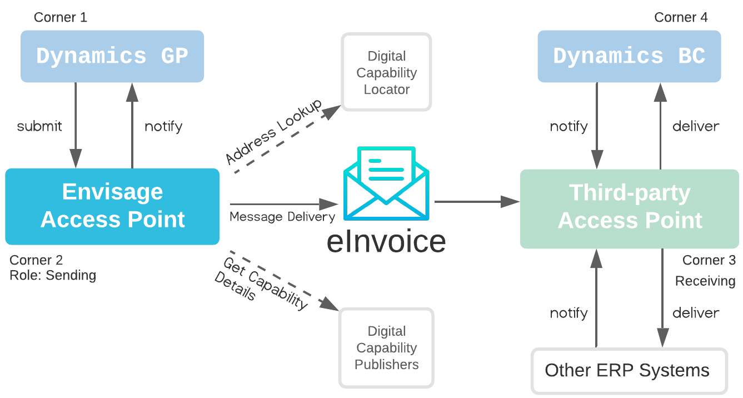

Account Receivable:
for AR--> there polling mechanism to pick posted invoices in GP and push to client PEPPOL access point.

- Aidacare creates invoice in GP.
- PostMaster Connect converts it into Peppol eInvoice format.
- Aidacare’s Access Point checks where the customer is registered.
- It sends the invoice to the customer’s Access Point.
- Customer’s finance system receives the invoice automatically.
So Aidacare is not calling SAP, Oracle, Xero, MYOB, TechnologyOne, Business Central, etc. directly. The customer’s own Access Point handles delivery into their finance system.

How does the Access Point know where to send the invoice?
It uses the customer’s Peppol ID.
For Australia, this is commonly based on identifiers such as the customer’s ABN.
The Access Point uses Peppol lookup services to find:
- Is this customer registered for Peppol?
- What document types can they receive?
- Which Access Point should receive the invoice?
- What address/certificate/security details are required?
OpenPeppol describes this as Addressing and Capability Lookup, with the Service Metadata Locator helping Access Points discover trading partner addressing details, similar to how the internet finds websites from domain names
The invoice is sent as a structured XML eInvoice, not PDF.
For Australia/New Zealand, the relevant standard is Peppol PINT A-NZ Billing, which defines invoice and credit note transactions and localises tax context such as GST.
GP data | eInvoice data
Customer number | Buyer party
Customer ABN / Peppol ID | Buyer electronic address
Invoice number | Invoice ID
Invoice date | Issue date
Item lines | Invoice lines
GST | Tax total
Total amount | Payable amount
PO number | Order reference

Account Payable
and for AP-> listening to Aidacare PEPPOL access point to give to Docuphase.
• Supplier sends Aidacare an eInvoice.
• PostMaster Connect receives/reads it.
• It checks vendor details, ABN, PO number, invoice number, tax/GST data.
• It send it to Docuphase/AP approval workflow
• If vendor/PO/tax code does not match, invoice is placed in error/exception queue.

